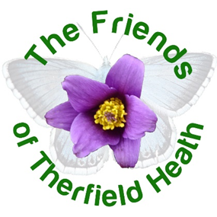

Become a ‘friend’ of Therfield Heath (and Greens)

The Friends of Therfield Heath:
- is a voluntary group
- works with the Conservators of Therfield Heath and Greens
- promotes and encourages the use of and access to Therfield Heath, including organising events
- raises awareness of the related bye laws and regulations
- encourages conservation protection, and improvement of the natural environment, and improved facilities for the users

Funds raised recently have and will go towards improving signage, creating an information booklet, providing maintenance equipment, and putting on monthly events for members and other local people.

Members receive:
- Newsletters
- Discounted fees for events, talks and activities

Contact us: friendsoftherfieldheath@gmail.com

www.facebook.com/friendsoftherfieldheath

www.friendsoftherfieldheath.org.uk
Therfield Heath and Greens
Therfield Heath is a special place. It is Common Land and most of it is a Local Nature Reserve and a Site of Special Scientific Interest. One area is also a Coronation Meadow.

It is owned by the Therfield Regulation Trust, which is a registered charity. It is managed by the Conservators of Therfield Heath and Greens.

Therfield Heath holds the status of a Site of Special Scientific Interest (SSSI) notified under Section 28 of the Wildlife and Countryside Act 1981. The main reason for the citation is the chalk grassland habitat and the specific grasses, flowers and insects associated with it.

Volunteering
​The Conservators frequently need help with work on the heath. If you’re interested in assisting with some of the maintenance tasks, please do get in touch with the Conservators by emailing the Clerk to the Conservators clerk.conservators.therfield@gmail.com

​Committee and social committee
Please do get in touch if you'd like to join our team or help organise social events at friendsoftherfieldheath@gmail.com
​
Events
Keep an eye out for our newsletter or facebook posts for upcoming events. Please let us know if you’d like us to run particular events, or even if you’d be interested in speaking at, or running an event.

Please complete this form online on www.friendsoftherfieldheath.org.uk or fill in and post this page to 29 Gage Close, Royston, SG8 7BE

MEMBERSHIP FORM
I would like to join the Friends of Therfield Heath and for them to hold my contact details for the purposes of managing my membership.

Name(s)
Tel no
E-mail
Postcode

Membership fees
£12 Individual membership
£16 Household membership
£ Optional donation
£ Total

Payment:
Cheque (made out to Friends of Therfield Heath)
Bank transfer (Friends of Therfield Heath, 39318768, 30-90-89, reference is your surname and last three postcode characters eg. Smith8JF)

Your information will be stored and processed by the Friends of Therfield Heath in accordance with our Privacy Policy, which can be found on our website. The Friends of Therfield Heath will never pass personal data to other organisations.

Communication preference:
Post Email Please don’t send me newsletters

Signed
Date

